**Software Design Specifications**

***Hotel Management System***

**Version: [1.0]**

|  |  |
| --- | --- |
| Project Code | *SE-2002* |
| Supervisor | *Miss Syeda Rubab Jaffar* |
| Co Supervisor | *Miss Zarnain Maryam Awan* |
| Project Team | *22k-4818 Mustafa Masood*  *22k-5195 Laiba Fatima*  *22k-5198 Sabina Rasheed* |
| Submission Date | *3 May 2024* |

Document History

|  |  |  |  |
| --- | --- | --- | --- |
| Version | Name of Person | Date | Description of change |
| *1* | *Laiba Fatima* | *25 April* | *Document Created, Introduction* |
| *2* | *Sabina Rasheed* | *25 April* | *Design Considerations* |
| *3* | *Sabina Rasheed* | *26 April* | *Design Strategy* |
| *4* | *Laiba Fatima* | *27 April* | *Detailed System Design* |
| *5* | *Mustafa Masood* | *27 April* | *Detailed System Design* |
| *6* | *Sabina Rasheed* | *27 April* | *Detailed System Design* |
| *7* | *Sabina Rasheed* | *28 April* | *System Level Architecture* |
| *8* | *Mustafa Masood* | *29 April* | *System Level Architecture* |
| *9* | *Laiba Fatima* | *29 April* | *System Level Architecture* |
| *10* | *Mustafa Masood* | *1 May* | *References, Appendices* |

Distribution List

|  |  |
| --- | --- |
| **Name** | **Role** |
| *Miss Syeda Rubab Jaffar* | Supervisor |
| *Miss Zarnain Maryam Awan* | Co Supervisor |

Document Sign-Off

|  |  |  |  |  |
| --- | --- | --- | --- | --- |
| **Version** | **Sign-off Authority** | **Project Role** | **Signature** | **Sign-off Date** |
| *1.0* | *Miss Syeda Rubab Jaffar* |  |  |  |
| *1.0* | *Miss Zarnain Maryam Awan* |  |  |  |
|  |  |  |  |  |
|  |  |  |  |  |
|  |  |  |  |  |
|  |  |  |  |  |
|  |  |  |  |  |

Document Information

| **Category** | **Information** |
| --- | --- |
| Customer | FAST-NU |
| Project | Hotel Management System |
| Document | Software Design Specification |
| Document Version | 1.0 |
| Status | Draft |
| Author(s) | 22k-4818 Mustafa Masood  22k-5195 Laiba Fatima  22k-5198 Sabina Rasheed |
| Approver(s) | Miss Syeda Rubab Jaffar |
| Issue Date |  |
| Document Location |  |
| Distribution | Advisor  Project Coordinator’s Office (through Advisor) |

Definition of Terms, Acronyms and Abbreviations

| **Term** | **Description** |
| --- | --- |
| ASP | Active Server Pages |
| DD | Design Specification |
| SDS | Software Design Specification |
| HMS | Hotel Management System |
| SRS | Software Requirement Specification |
| API | Application Programming Interface |
| UML | Unified Modeling Language |
| E/R | Entity Relation |
| DFD | Data Flow Diagram |

***Table of Contents***

*1. Introduction …………………………………………………………….........…………........................……....7*

*1.1. Purpose of Document …………………………………………………………….........…………................7*

*1.2. Intended Audience …………………………………………………………….........………….....................7*

*1.3. Document Convention …………………………………………………………….........…………...............7*

*1.4. Project Overview …………………………………………………………….........…………................…....7*

*1.5. Scope …………………………………………………………….........…………........................…….........7*

*2. Design Considerations ……………………………………....................................…………………….........8*

*2.1. Assumptions & Dependencies …………………………………….....................…………………….........8*

*2.2. Risks and Volatile Areas ……………………………………..............................…………………….........8*

*3. System Architecture ……………………………………..............................…………..........………….........9*

*3.1. System Level Architecture ……………………………………..............................…………........….........9*

*3.2. Software Architecture ……………………………………..............................…………..........………….10*

*4. Design Strategy …………………………………….............................…………..........…………..............11*

*5. Detailed System Design …………………………………….............................…………..........………….12*

*5.2. Application Design …………………………………….............................…………..........………….......13*

*5.2.1. Sequence Diagram …………………………………….............................…………..........…………...15*

*5.2.1.1 Room Reservation …………………………………….............................…………..........…….........15*

*5.2.1.2 Payment Collection …………………………………….............................…………..........………….16*

*5.2.1.3 Order Food …………………………………….............................…………..........………..........…...17*

*5.2.1.4 Extended Booking …………………………………….............................…………..........…………...18*

*5.2.1.5 Update Room Inventory …………………………………….............................…………..........…….19*

*5.2.2 State Diagram …………………………………….............................…………..........……….........…...20*

*5.2.2.1 Room Reservation …………………………………….............................…………..........…….........20*

*5.2.2.2 Payment Collection …………………………………….............................…………..........………….20*

*5.2.2.3 Order Food …………………………………….............................…………..........………..........…...21*

*5.2.2.5 Update Room Inventory …………………………………….............................…………..........…….22*

*5.2.3 Activity Diagram ..............…………………………………….............................…………..........…......23*

*5.2.3.1 Room Reservation ..............…………………………………….............................…………............23*

*5.2.3.2 Payment Collection ..............…………………………………….............................…………...........24*

*5.2.3.3 Order Food ..............…………………………………….............................…………..........…….......25*

*5.2.3.4 Extended Booking ..............…………………………………….............................………….............26*

*5.2.3.5 Update Room Inventory ..............…………………………………….............................…………....27*

*6. References ..............…………………………………….............................…………..........……...............28*

*7. Appendices ..............…………………………………….............................…………..........……..............28*

# Introduction

*The Hotel Management System is a tool for booking rooms of hotel through online process by the customer.*

## Purpose of Document

The main purpose of this document is to illustrate the requirements of the project Hotel Management

System. This document describes the design decisions, architectural design and the detailed design

needed to implement the system. It provides visibility in the design and provides information that is

essential for software support. The document provides a detailed description of functional and

nonfunctional requirements put forward by the client.

## Intended Audience

The intended audience for this Hotel Management System document is the project stakeholders,

including developers, project managers, and quality assurance teams involved in the development and

implementation of the Hotel Management System. The people who will benefit from the final product are

the Receptionist, Customer and Administration.

## Document Convention

*Font used for this document is “Arial Italic” for paragraphs and “Arial Bold Italic” for Headings and Sub-Headings. Sizes are different for every type of text; for the title the size is 16, sub-headings are size 14 and for the text written in paragraphs, the size is 10.*

## Project Overview

The Hotel Management System is designed to facilitate online booking of hotel rooms for customers. It will provide a user-friendly interface for customers to browse available rooms, make reservations, and manage bookings. The system will also include administrative functionalities for hotel staff to manage room inventory, reservations, and customer information.

## Scope

*The hotel management system aims to provide comprehensive management functionalities for hotel operations. It includes functionalities such as room management, customer management, food management, and backup and recovery. The system will facilitate booking, allocation, deallocation of rooms, and ordering of food items. It will also incorporate automatic backup and recovery features to ensure data integrity and system reliability.*

The software to be produced will help the customers of the Hotels to reserve rooms and other facilities of the hotel from anywhere. The core part of the project is the reservation and the booking system to keep track of the reservations and room availability

These are not in the project scope

* *Integration with external systems such as accounting software.*
* *Advanced security features like biometric authentication.*

# Design Considerations

## Assumptions and Dependencies

*Assumptions and dependencies for the system and project are already captured in the SRS document.* Additionally, we depend on third-party APIs for services such as payment processing and mapping. *This section highlights new issues that are only relevant to design.*

* *Scalability: The system design will accommodate scalability requirements to handle increased demand during peak seasons or business expansion.*
* *Security: Design will prioritize security measures to protect sensitive guest information, including secure user authentication, data encryption, and access controls.*

## Risks and Volatile Areas

* New Requirements: The introduction of new requirements during the development process could impact on the design. To mitigate this risk, we will conduct regular reviews of the SRS and collaborate closely with stakeholders to address any changes promptly.
* Technology Changes: Rapid advancements in technology may necessitate updates to the system's design to incorporate new tools or frameworks. To address this risk, we will maintain awareness of emerging technologies and allocate time for research and experimentation.
* User feedback: User feedback and evolving user preferences may drive design changes to enhance the user experience and meet customer expectations. Agile development methodologies will facilitate iterative design updates based on user feedback.
* User Acceptance: Ensuring that the system meets the needs and expectations of users is crucial for its success. We will involve stakeholders and end-users in the design process through user testing, feedback sessions, and usability studies to address any usability concerns or issues.
* Security Vulnerabilities: The system must protect sensitive guest information and financial data from security threats. We will store all data in files.

# System Architecture

The system architecture comprises of the overall design, internal and external components and different patterns to describe how the system works.

## System Level Architecture

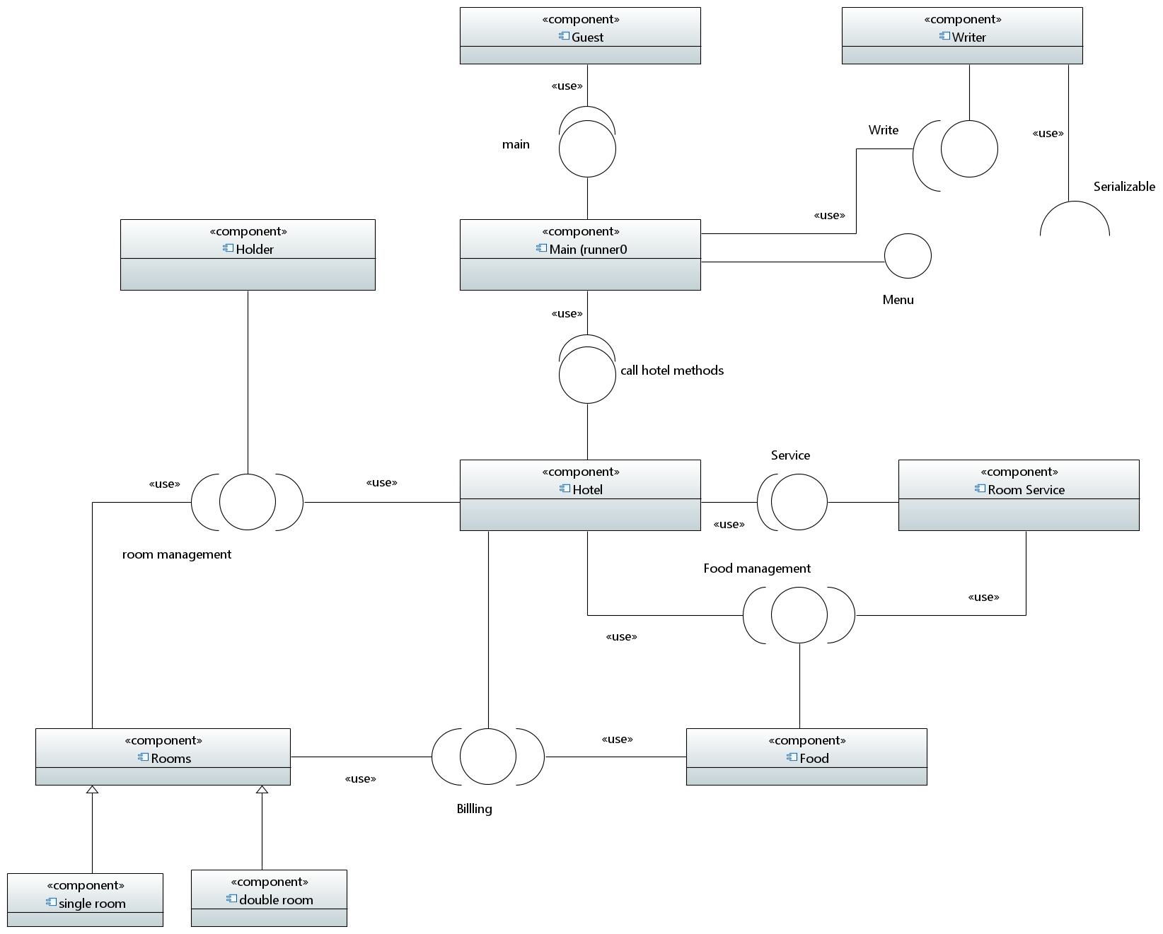

This diagram illustrates the interaction points between the different components of Hotel Managment Systems along with the required and provided interfaces for each component and the details that any components require.

## Software Architecture (deployment diagram)

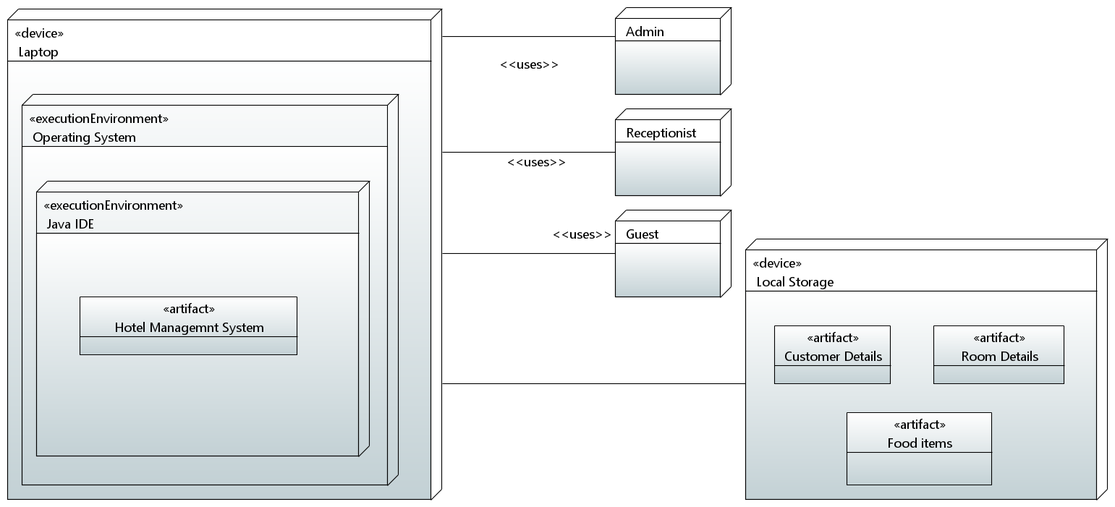

* *The hotel management system deployment diagram illustrates the interaction between client devices and the software application, which comprises modules for reservation management, billing, room service, and more. A database server stores crucial system and client data. This diagram provides a concise overview of the system's architecture and deployment environment.*

# Design Strategy

The designs for this overall architecture went through story boarding with team members and stakeholders. The components were divided and assigned to each member with a deadline. It was needed to implement them one at a time and check for any errors in the code before deploying it into the main component.

Future System Extension: The design strategy for the hotel management system anticipates future enhancements by employing a modular and scalable architecture to accommodate seamless integration of new features. Ensuring minimal disruption during system evolution, prioritizing stability and continuity of operations.

System Reuse: The design is specifically made for this “Hotel Management System” so if needed it can only be used with modifications to it depending on the system we are working on. To maximize efficiency and reduce development time, the design strategy emphasizes identification and categorization of reusable components within the system. Leveraging existing components to avoid redundancy and accelerate development efforts.

User Interface Paradigms: Our program will be executed in a console-based environment. We have designed intuitive command-line interfaces for ease of interaction by implementing clear and concise prompts and menus to guide users effectively prioritizing usability and accessibility without graphical interfaces through thoughtful design choices.

Data Management: The user and system data are stored in files to facilitate easy access and manipulation within a console-based environment by implementing file management techniques to organize and manage data effectively. Developing robust backup and recovery mechanisms to safeguard against data loss.

* Concurrency and Synchronization: To manage concurrent operations effectively within a console-based system, the design strategy Ensuring smooth communication and coordination between system components to minimize errors and optimize performance.

# Detailed System Design

***Class Diagram***

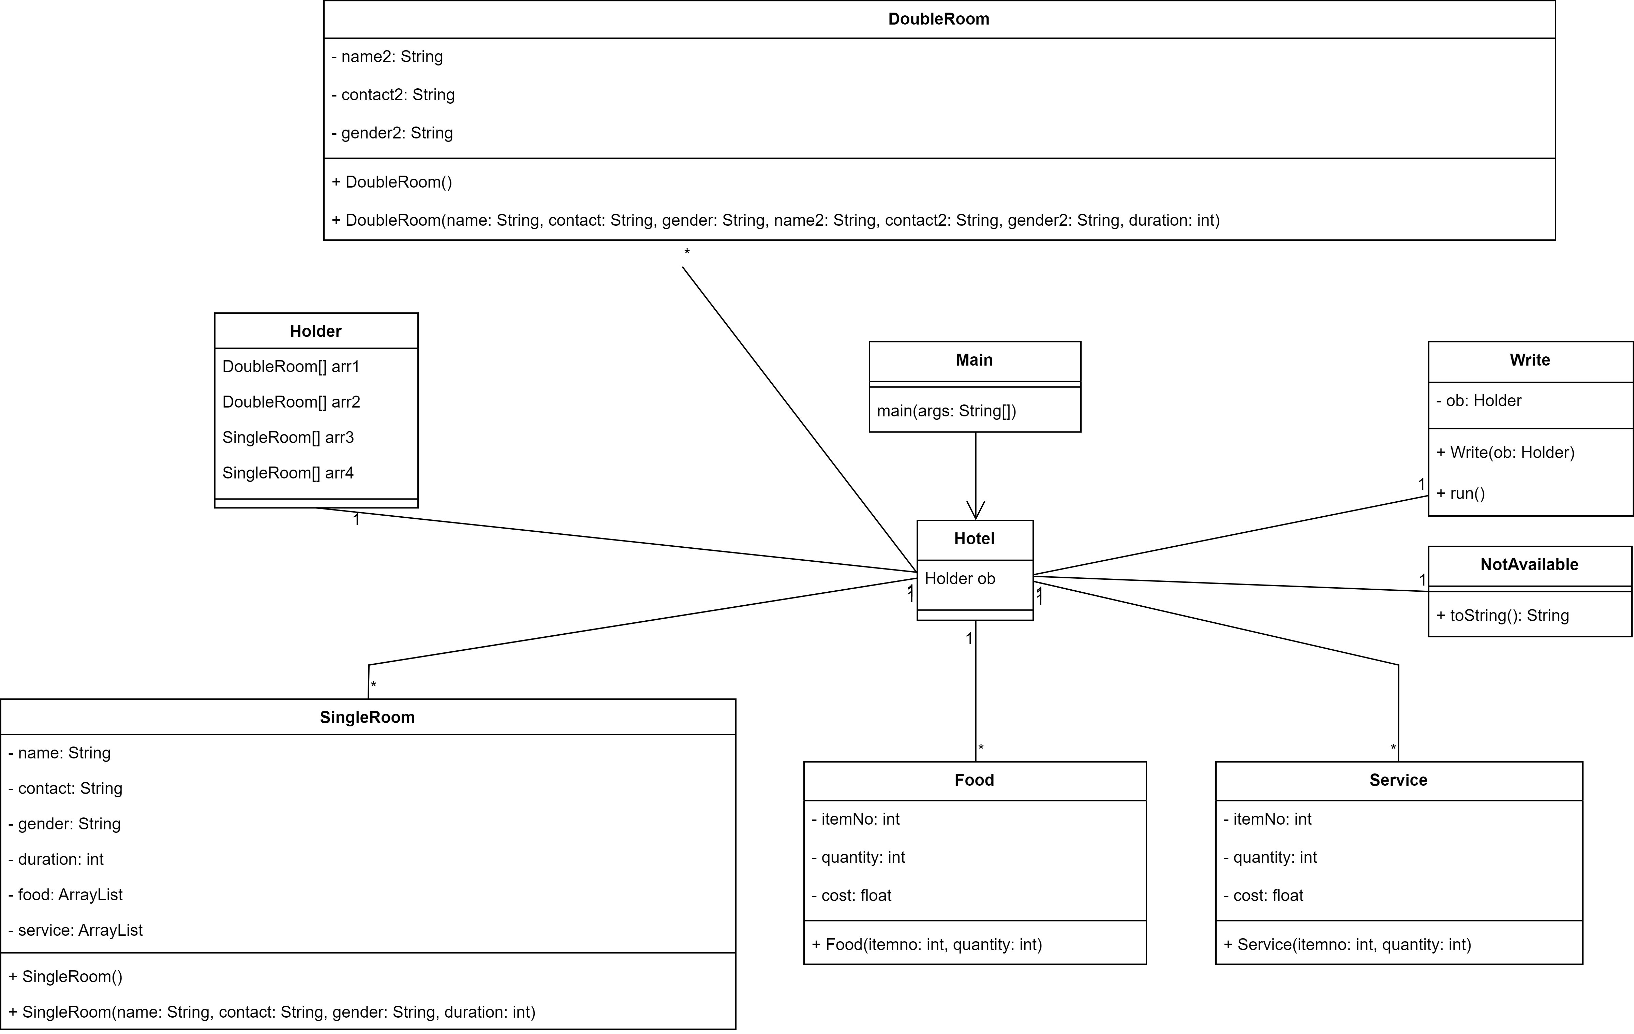

## 5.2 Application Design

***Collaboration Diagram***

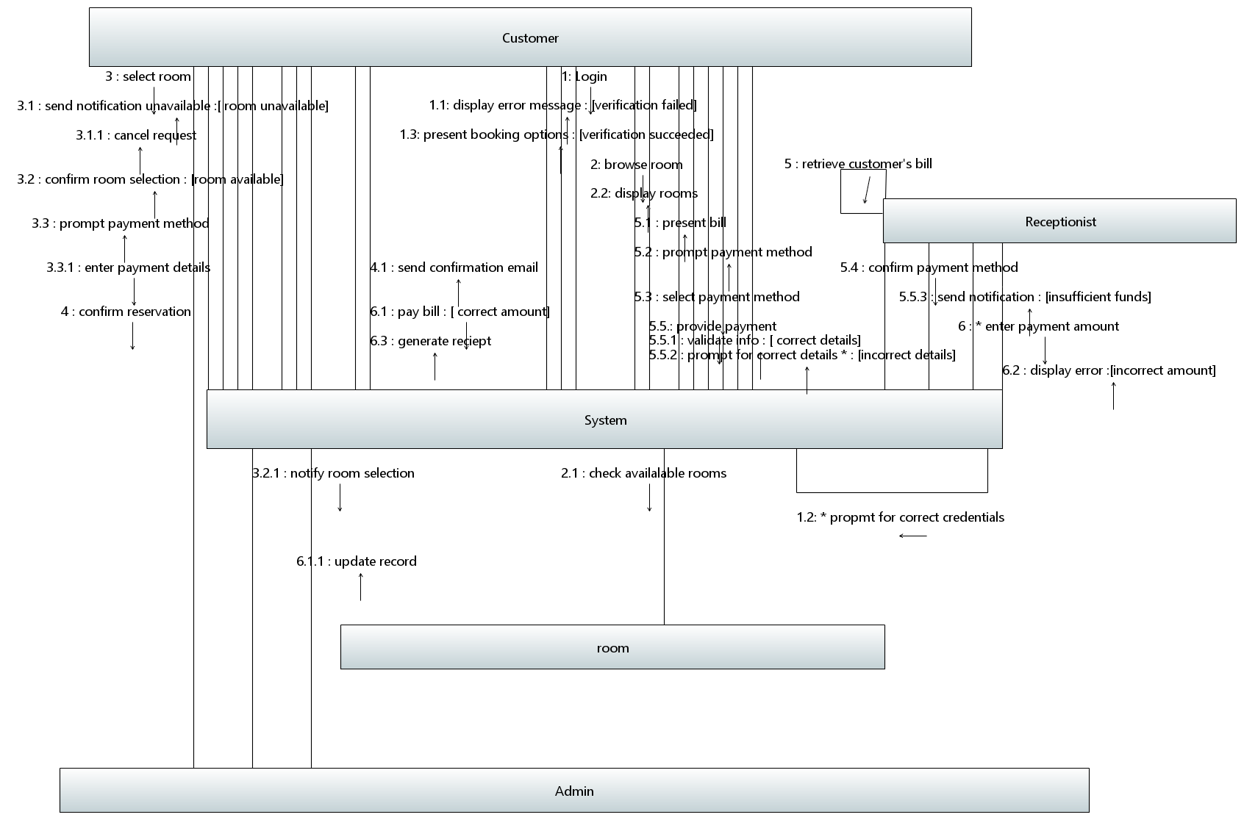

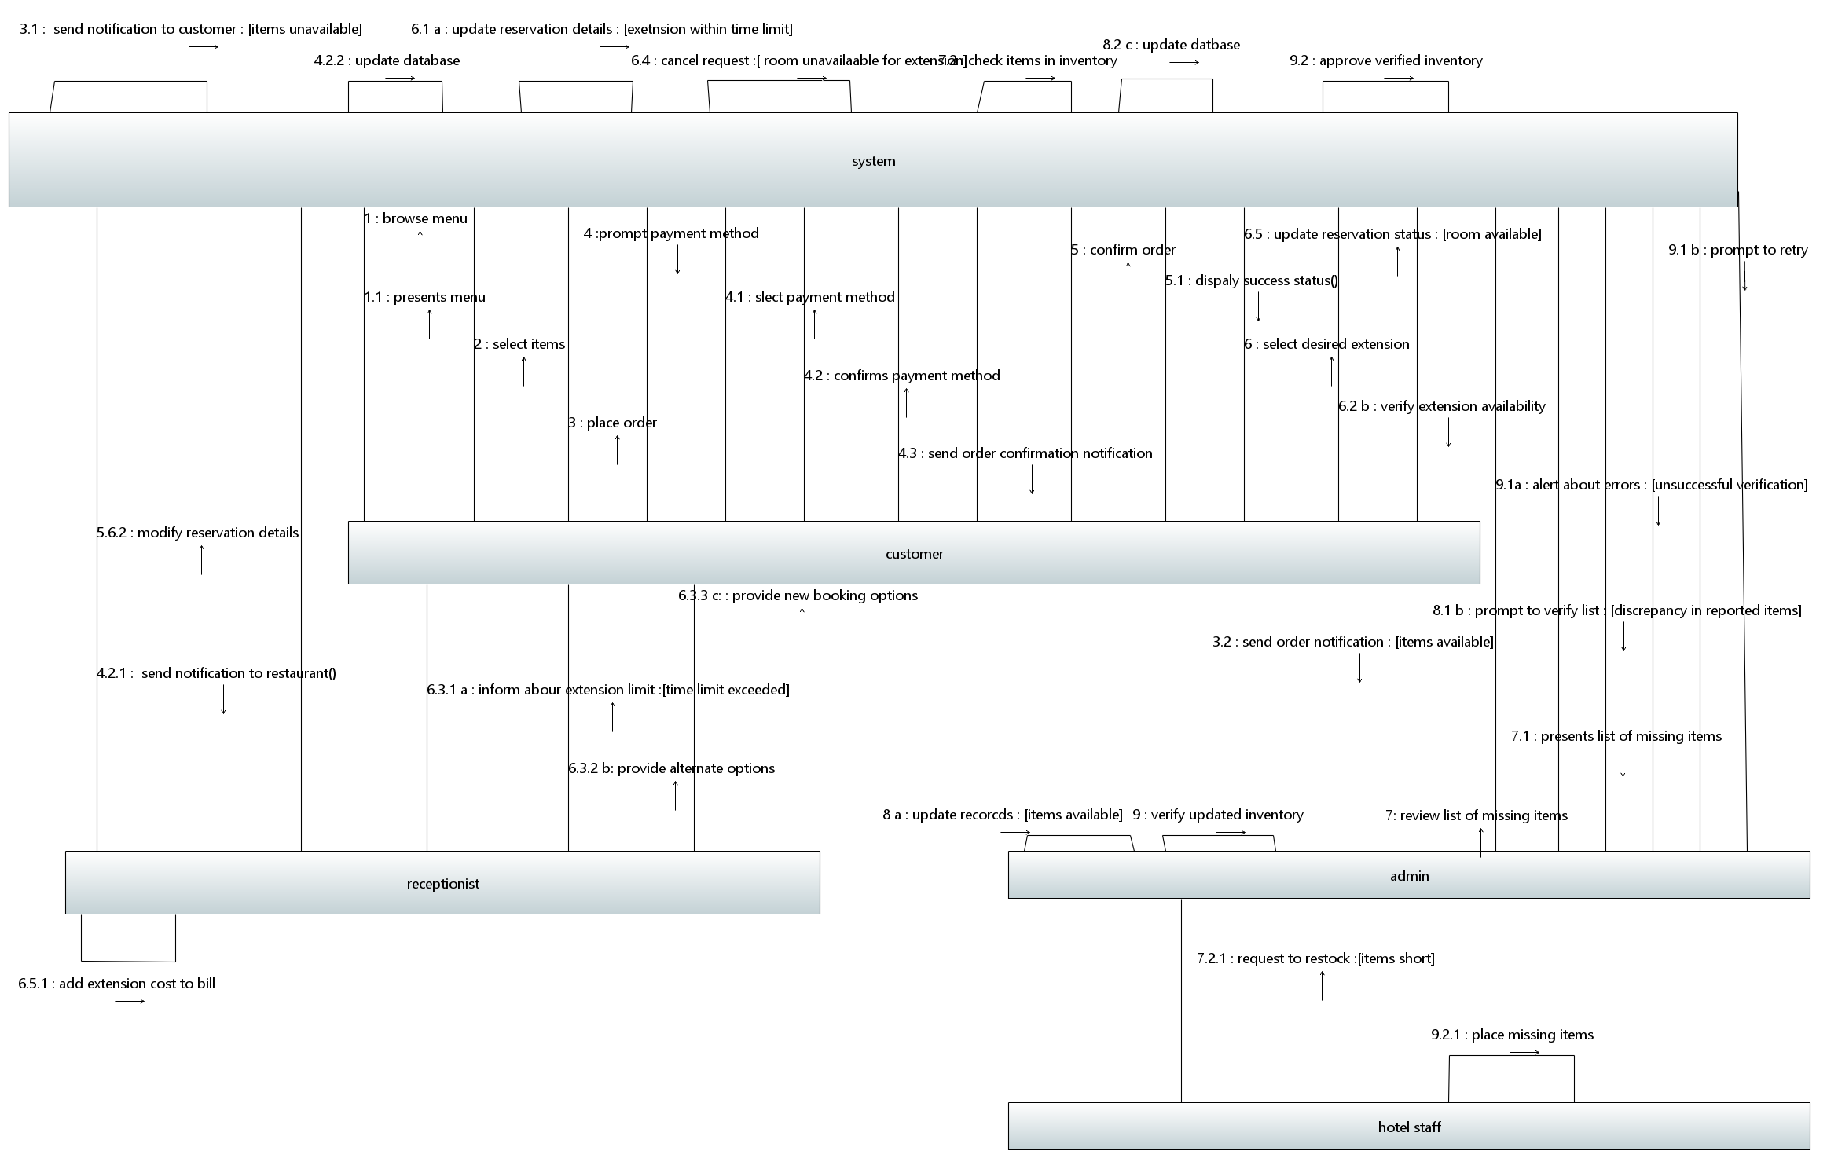

This diagram above is the collaboration diagram of the system which shows the sequence using message numbering and interaction between the objects of our system. All the actions are being done by the user in a console-based environment with proper prompts and options.

### 5.2.1 Sequence Diagram

#### 5.2.1.1 Room Reservation

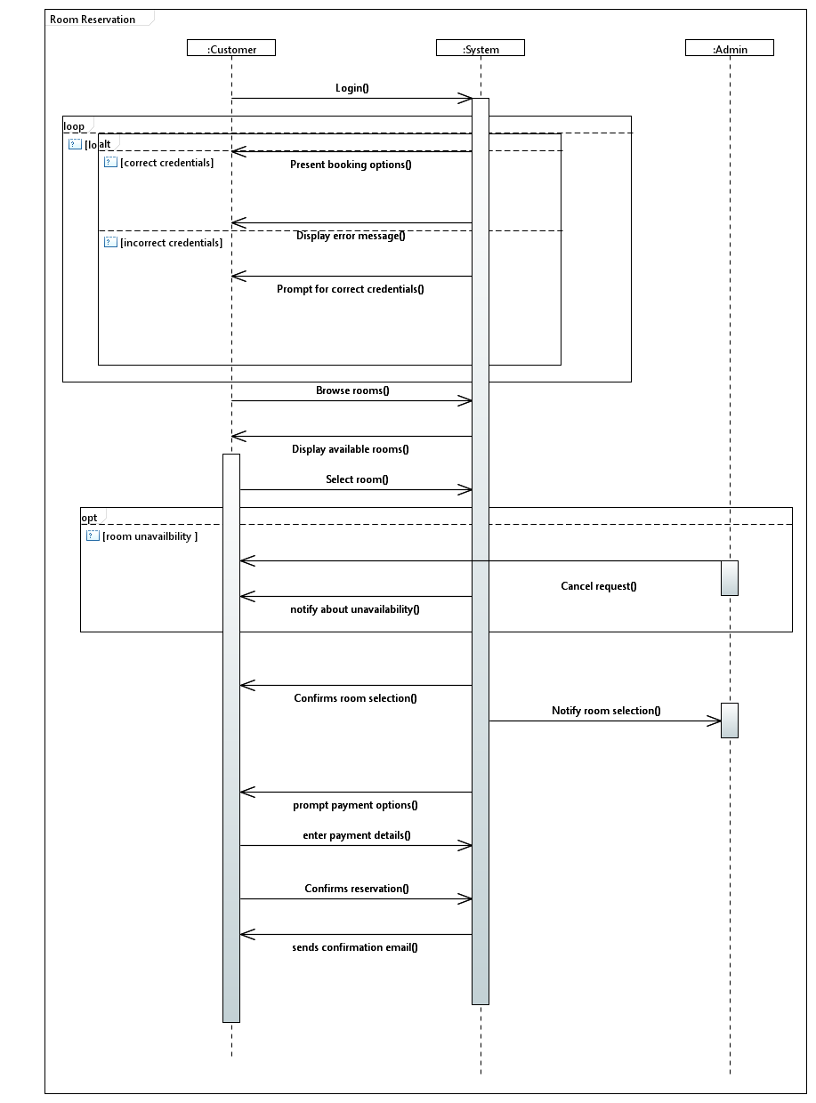

This diagram represents the main flow of the room reservation process along with alternative scenarios such as incorrect login credentials and room unavailability. Additionally, it includes an optional path where the admin can cancel the booking request.

#### 5.2.1.2 Payment Collection

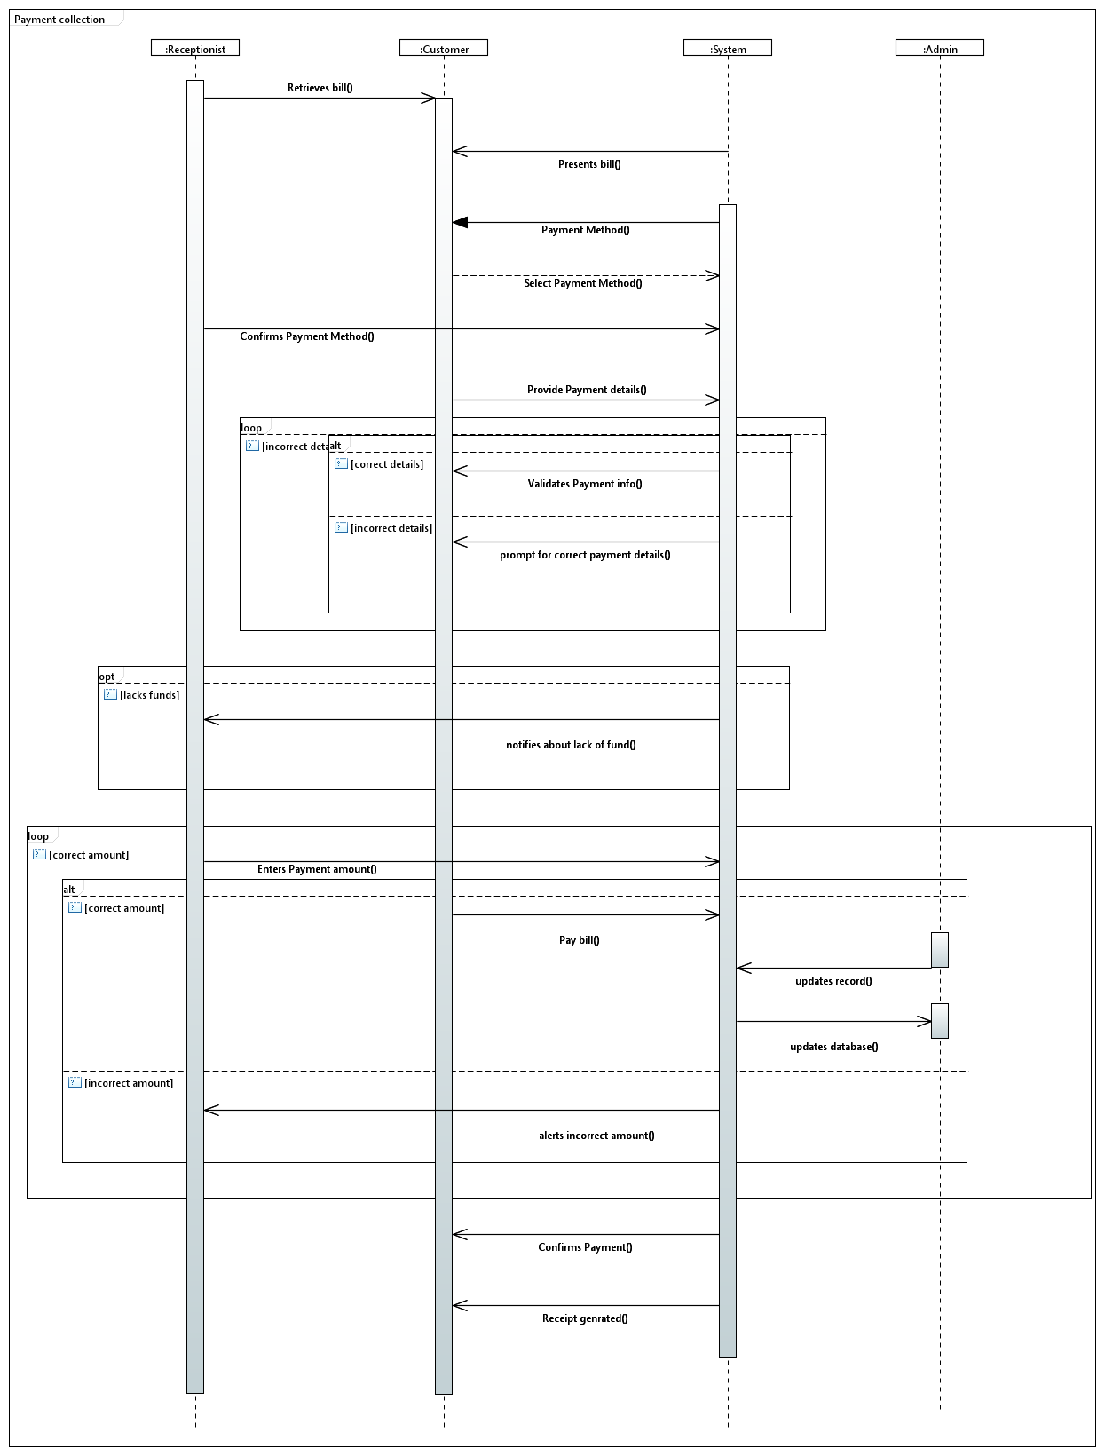

This diagram depicts the interactions between the Customer, Receptionist, Admin and System during the payment collection process. It includes the main steps outlined in the scenario, along with alternate scenarios for handling invalid payment details and incorrect payment amounts.

#### 5.2.1.3 Order Food

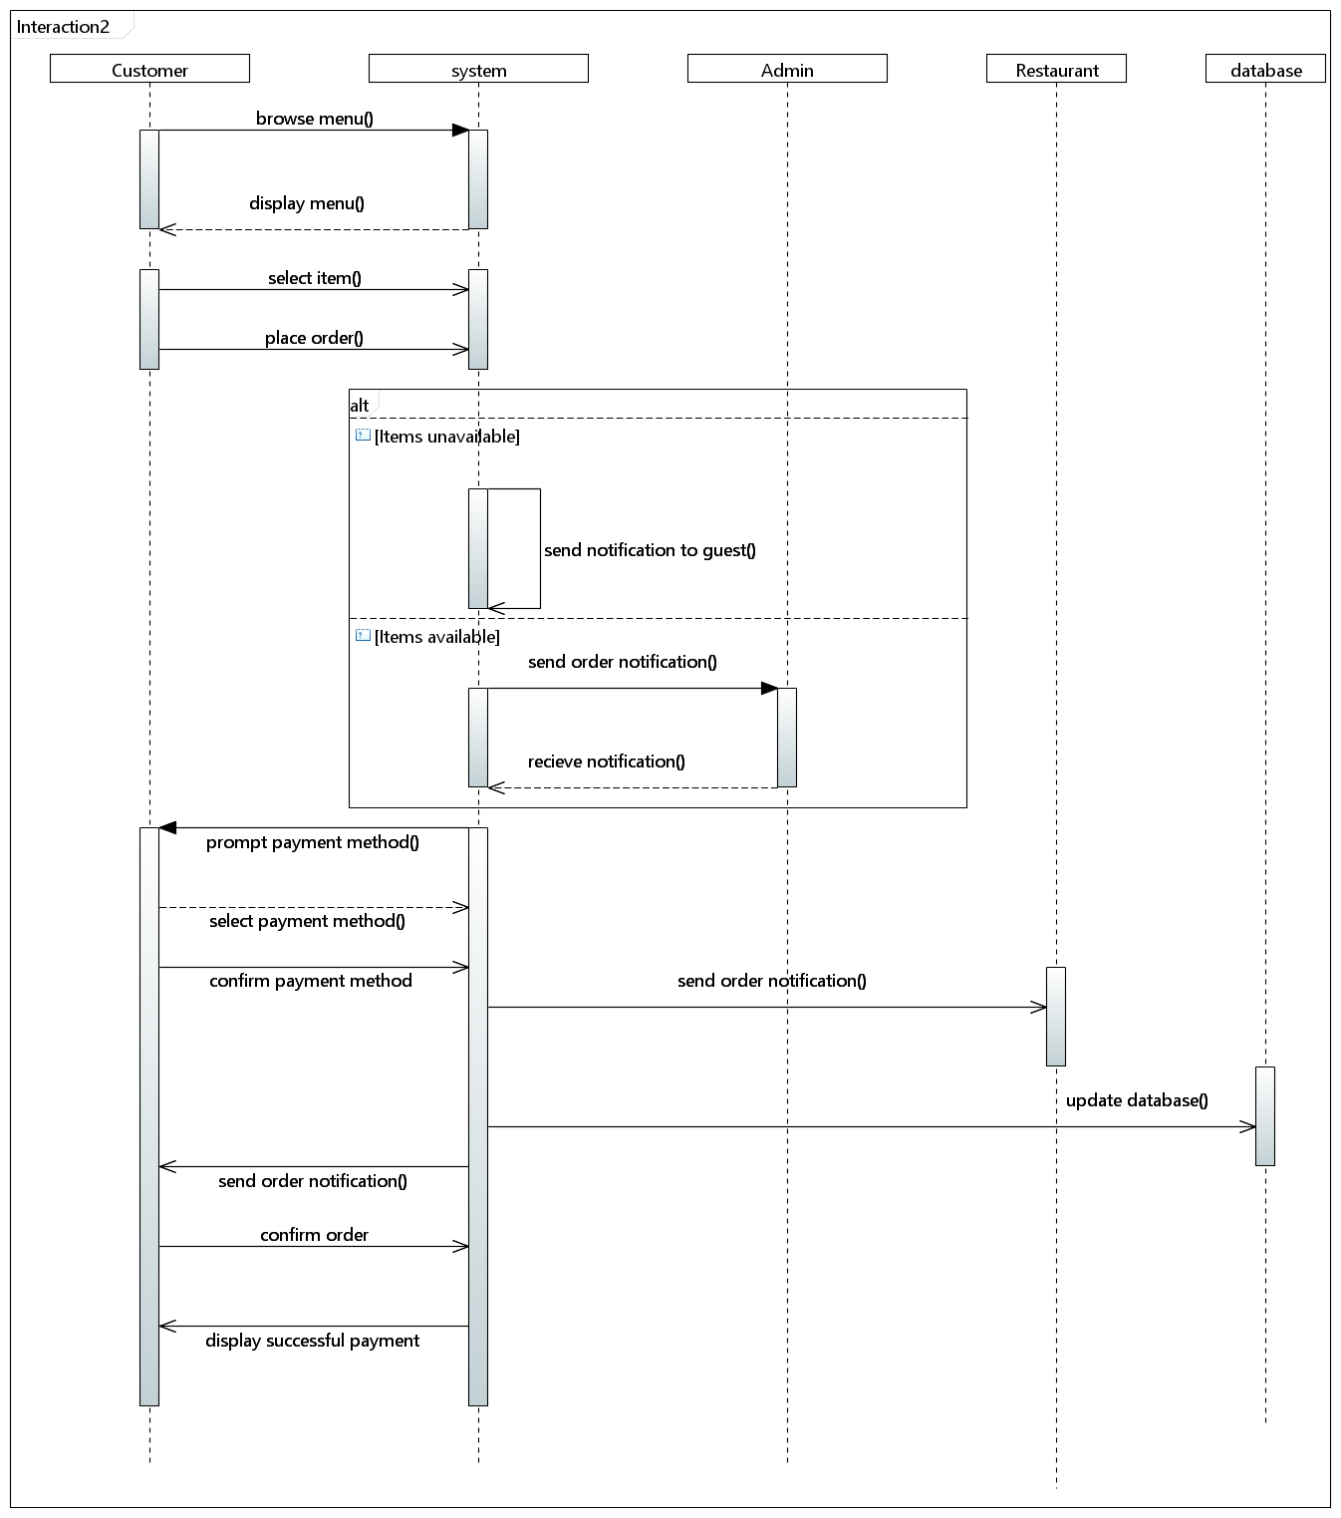

*The sequence diagram illustrates the process of ordering food, showcasing interactions between the user interface, backend systems, and external services like payment gateways. It delineates steps from item selection to checkout, emphasizing communication flows and decision points like inventory updates and payment processing.*

#### 5.2.1.4 Extend Booking

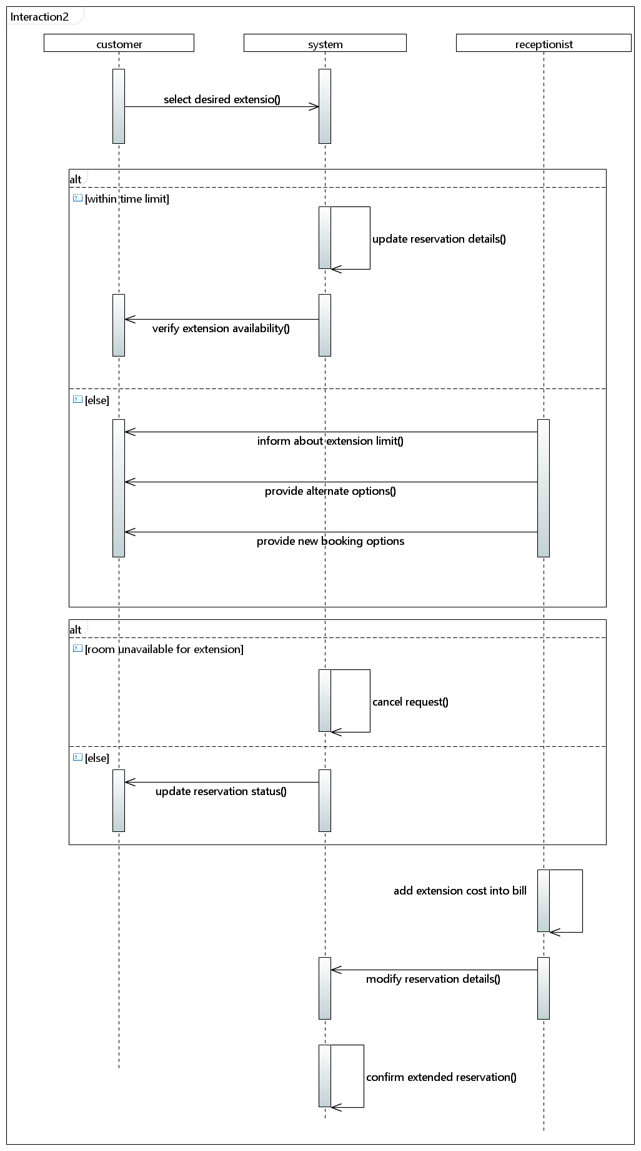

*The sequence diagram outlines the extension process for a booked room in a hotel, demonstrating interactions between the user, booking system, and receptionist. It depicts steps from the user request for extension to the backend updating the reservation, emphasizing communication flows and decision points like availability checks and confirmation of the extended booking.*

#### 5.2.1.5 Update Room Inventory

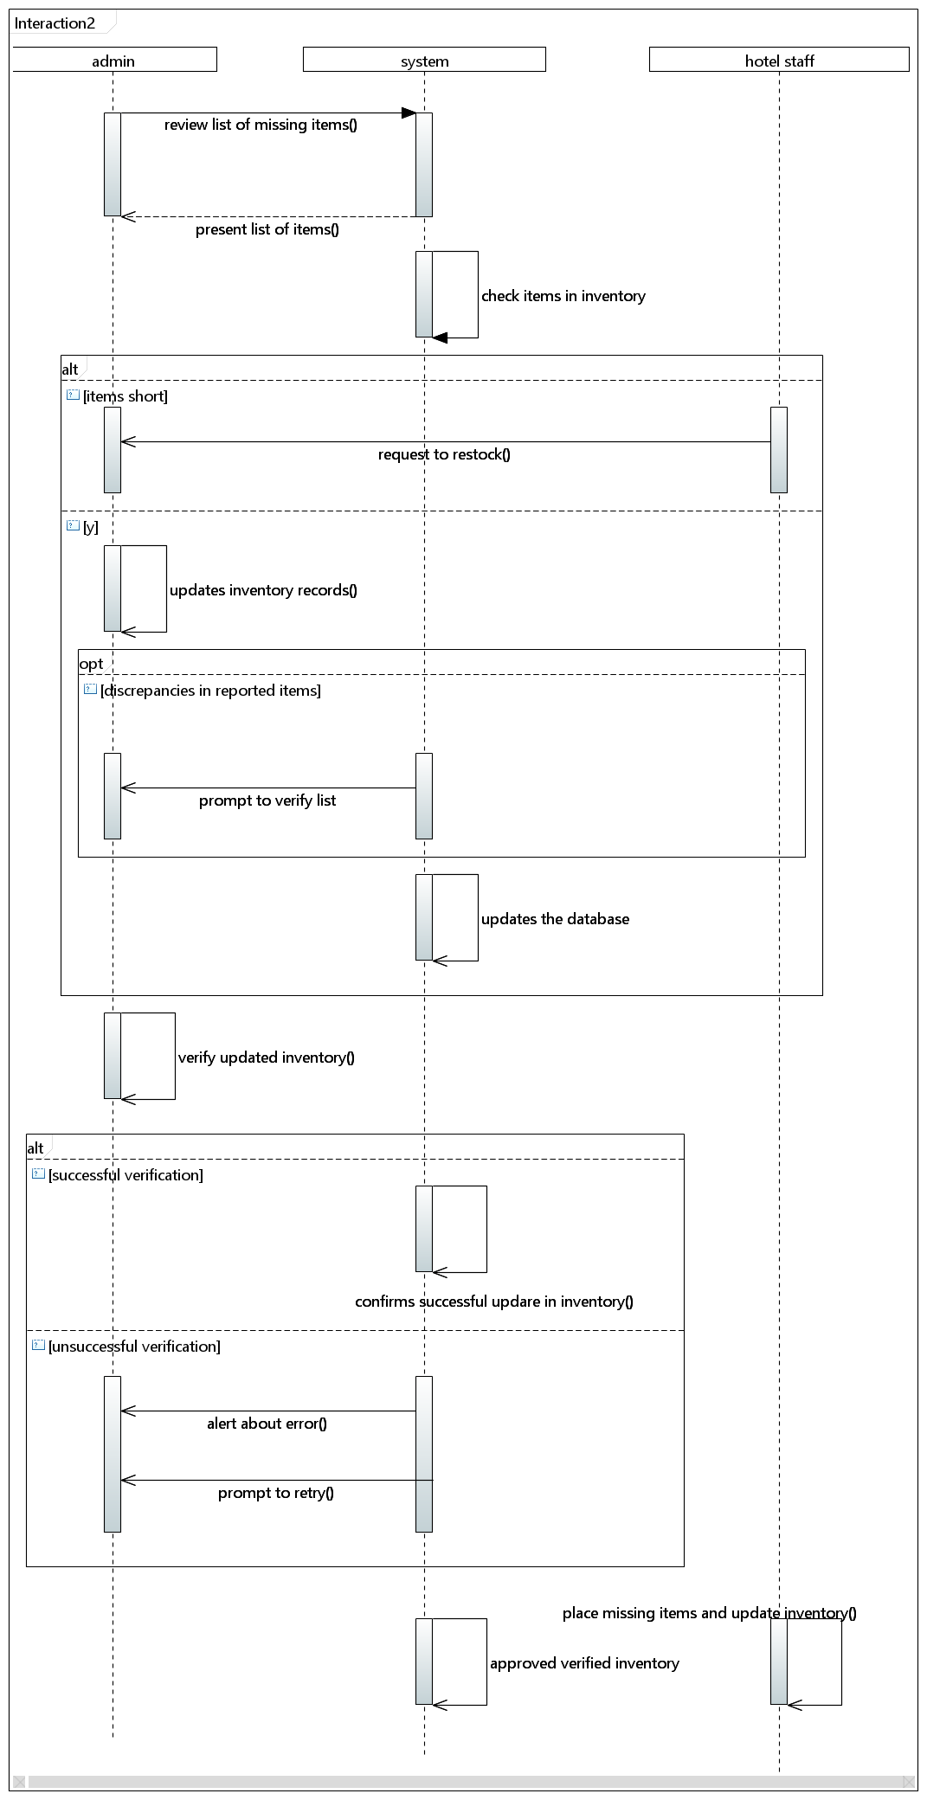

*The sequence diagram illustrates the room inventory updating process, ensuring restocking of missing items if available, or ordering if not, highlighting decision points like availability checks.*

### 5.2.2 State Diagram

#### 5.2.2.1 Room Reservation

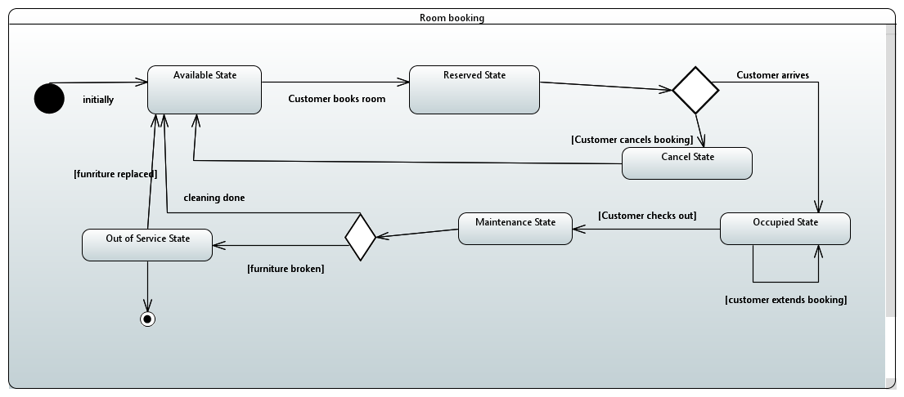

Transitions between states are depicted by arrows, showing how the system progresses from one state to another based on user actions or system responses. This diagram captures the flow of the ‘Room’ object and the extended booking.

#### 5.2.2.2 Payment Collection

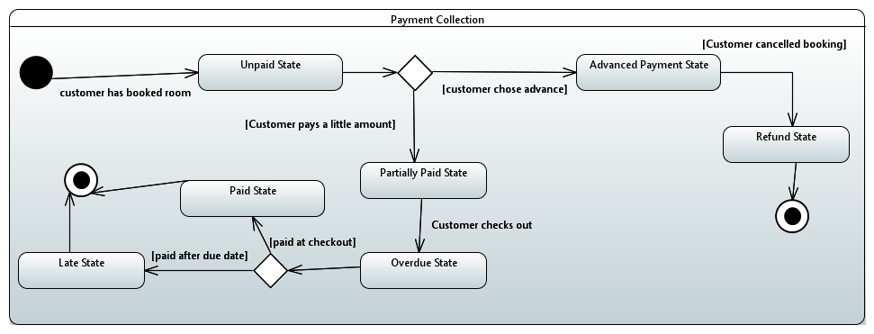

The diagram shows the states that ‘Payment’ object will be transitioned into. Each state represents a specific stage in the process, and transitions indicate the progression from one state to another based on actions taken.

#### 5.2.2.3 Order Food

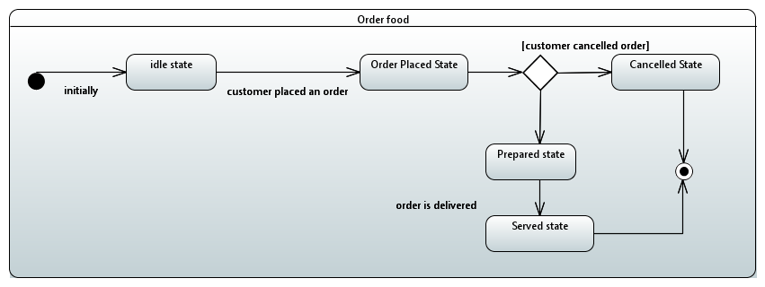

The "Order Food" diagram shows how you go from looking at the menu to placing your order, confirming your payment, and then letting the restaurant know about your order.

#### 5.2.2.5 Update Room Inventory

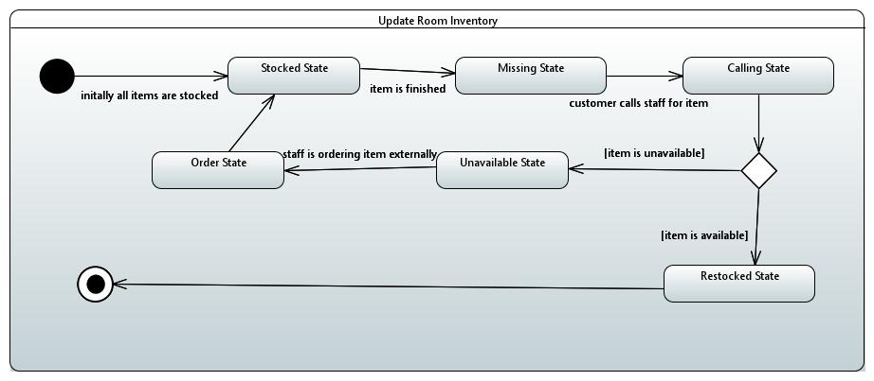

The diagram outlines how room availability information is managed. It starts with receiving updates on room status, then proceeds to process these updates and reflect them accurately in the inventory system.

#### 5.2.3 Activity Diagram

*The activity diagrams defined below are for each use case which were specified in the SRS*

5.2.3.1 Room Reservation:

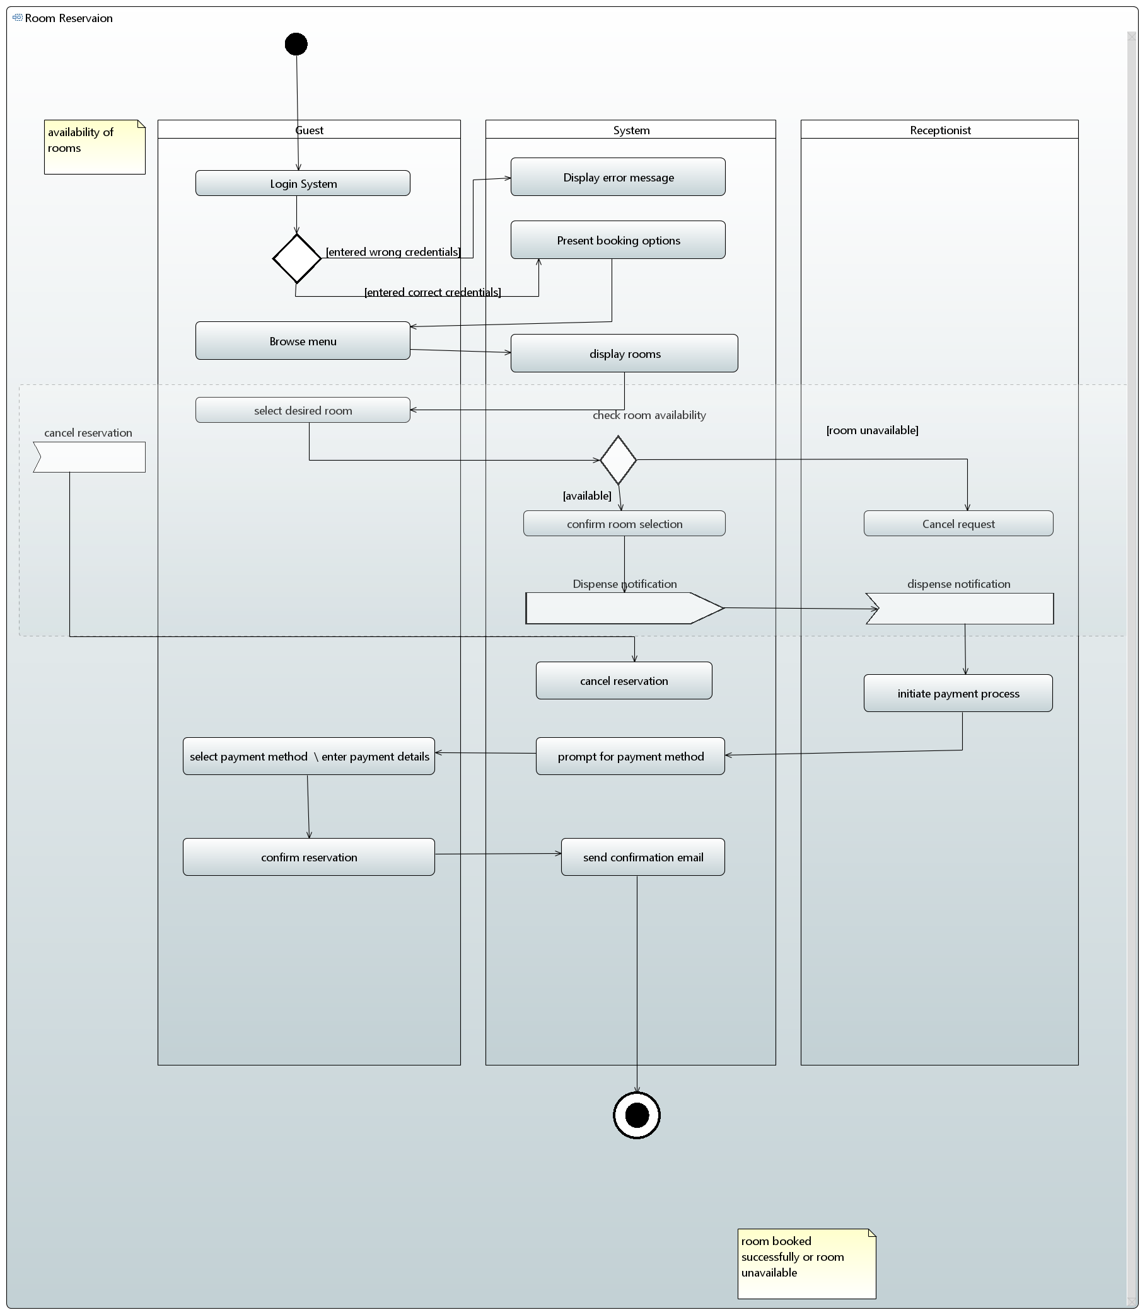

5.2.3.2 Payment Collection

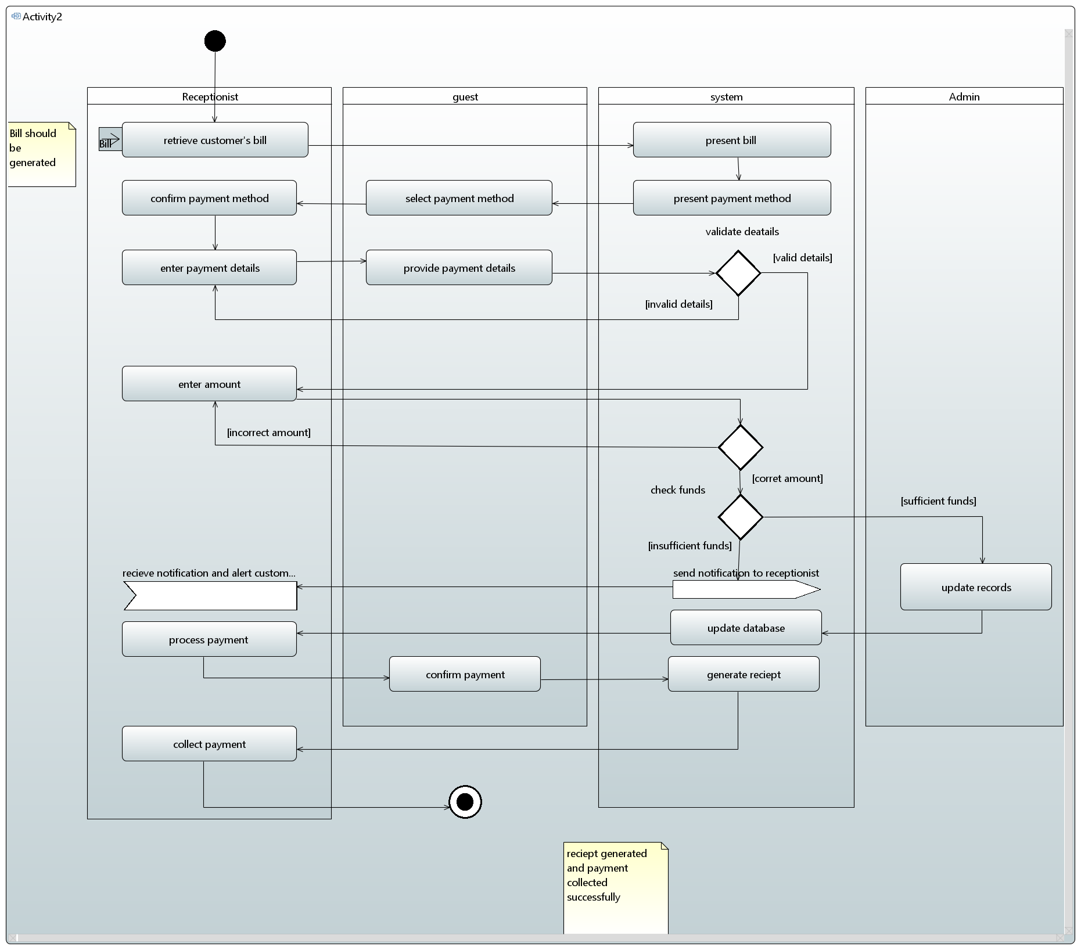

5.2.3.3 Order Food

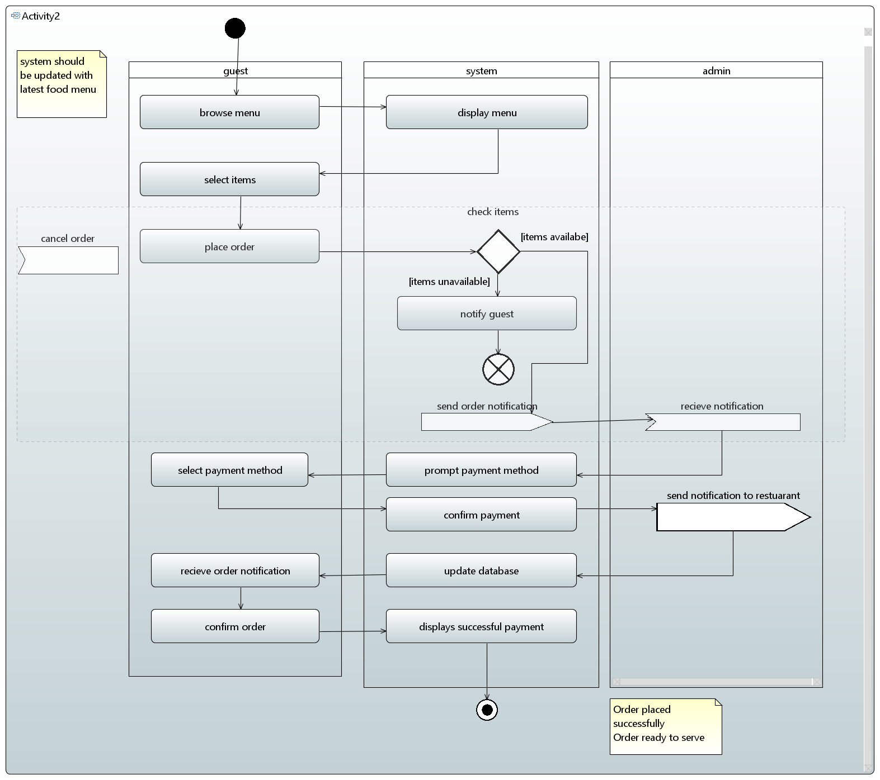

5.2.3.4 Extend booking 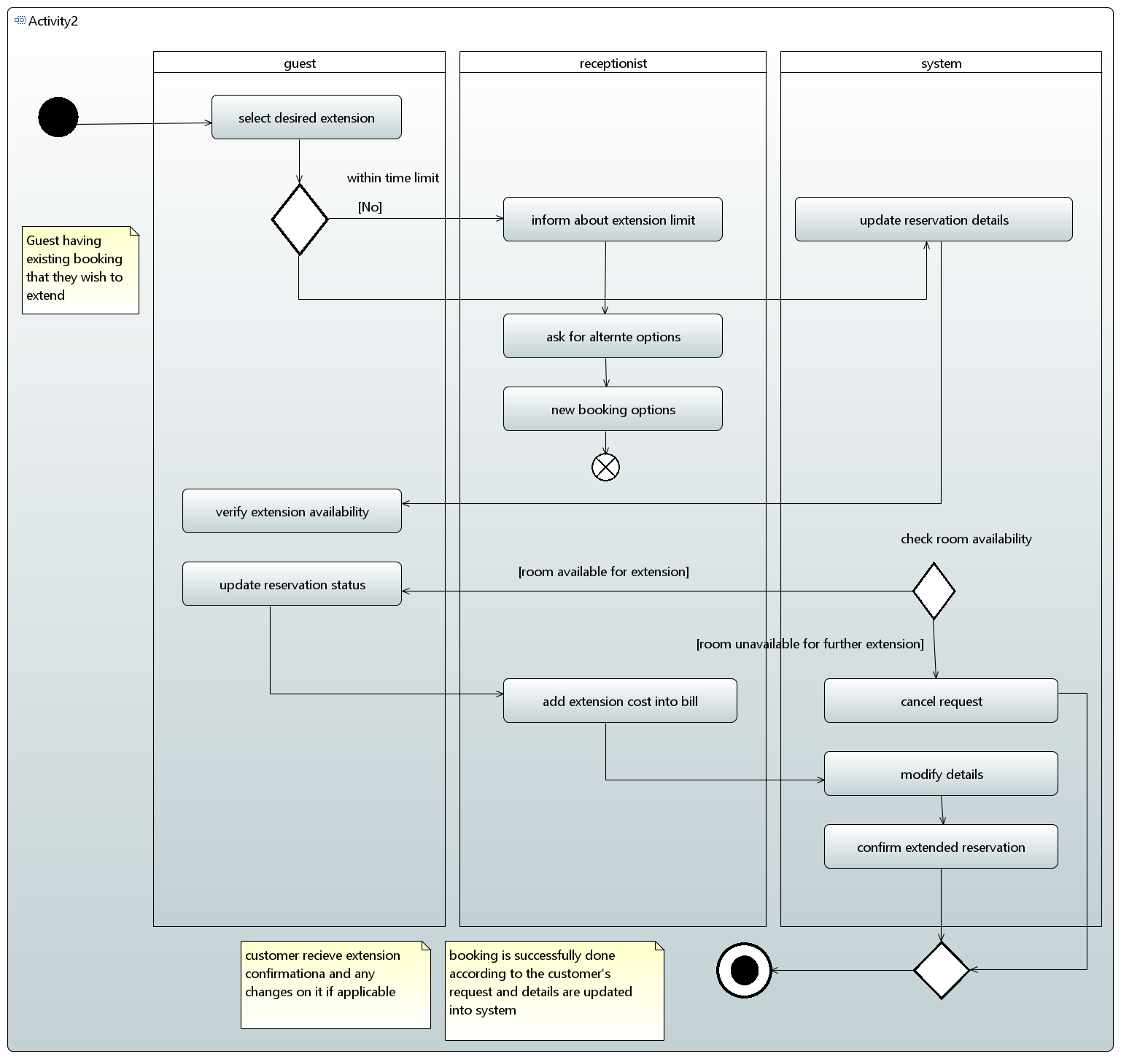

5.2.3.5 Update room inventory

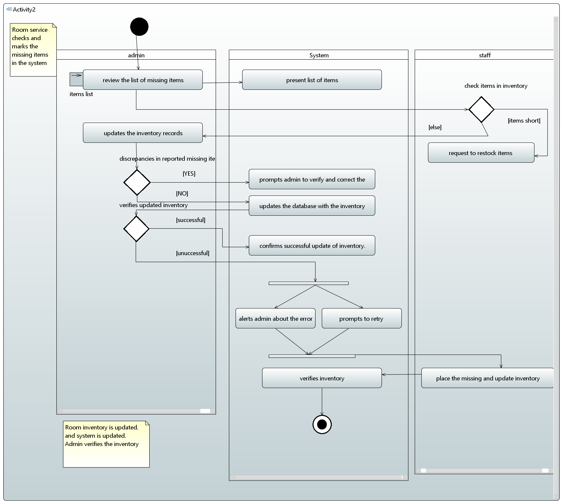

# References

* Software Engineering 9th Edition, Ian Sommerville
* *Lecture slides*
* SRS Document previously submitted
* *Requirement Engineering:* [*http://morse.inf.unideb.hu/valseg/gybitt/07/ch02.html*](http://morse.inf.unideb.hu/valseg/gybitt/07/ch02.html)
* *Hotel Management System:* [*https://www.scribd.com/doc/63824633/Hotel-ManagementSystem*](https://www.scribd.com/doc/63824633/Hotel-ManagementSystem)
* *Case Study:* [*https://www.scribd.com/doc/27927992/Hotel-Management-Case-Study*](https://www.scribd.com/doc/27927992/Hotel-Management-Case-Study)
* *Requirement Engineering:* [*https://en.wikipedia.org/wiki/Requirements_engineering*](https://en.wikipedia.org/wiki/Requirements_engineering)

# Appendices

# *No information to be added*